**Economic Project – Product Recalls**

**By Group 2**

**Weijing Wang**

**Le Yang**

**Xiaoyun Zhao**

**Nikhilesh Rajeev**

**Neeti Panjwani**

**Ping Shi**

**ALY6080 – Integrated Experiential Learn**

**Professor: Kristen Drobnis**

**Northeastern University - College of Professional Studies**

**2020.03.18**

For this week’s project, we have 4 parts. They are topic explaining, impact to Conmed, data elements review and charts build. We will illustrate our thoughts and findings in the following.

**Part 1. Topic explaining – Product Recalls**

Product recall in the medical device industry refers to the process through which a manufacturer of a medical device is forced to correct, modify, or eliminate an action or device if it violates the laws of the Food and Drug Administration (FDA). Since 2016, about 80 medical devices have been recalled. In fact, 2019 had the biggest number of recalled devices (Pedersen, 2019). Recalls are meant to reduce the possible health risks associated with a specific device. However, proper healthcare data governance can improve the quality of medical devices and healthcare services, thereby reducing costly recalls.

In a clinical setup, healthcare data governance can be used to collect information that can be used to gauge the effectiveness of a device in promoting quality healthcare. Adequate data management in healthcare institutions can help the nurses, doctors, analysts, and other relevant stakeholders to determine the accuracy, usefulness, and appropriateness of a medical device (Sanders, 2016). In 2019, ConMed experienced medical device recalls for the product called *Anchor Tissue Retrieval System*. FDA data showed that the ConMed’s Anchor Tissue Retrieval system is Class II Recall, and it poses no danger of causing death or severe conditions, but there are some health and safety risks involved.

Therefore, this project seeks to identify how healthcare data management can reduce the number and the possibilities of medical device recall in the ConMed company. Medical device recalls have many steps that make the process costly and time-consuming. Medical devices can be recalled because of the reasons such as packing and shipping in a container which is not sterile, ineffective device design, defective software, and other issues. Proper healthcare data management in the ConMed company is essential in reducing the prevalence of recalls. It can save the company's resources while at the same time improving healthcare service delivery.

**Part 2. Impacts to Conmed**

1. **Incur High recall costs.**

Recall costs include the costs that have been generated in the production and sales process, and the new costs that Conmed needs to invest in recalling the product. In addition, if consumers are notified of recall information, they usually need to rely on the media, so Conmed would face higher notification costs to the media. If the product has caused harm to the user ’s body, Conmed would also face a series of lawsuits, compensation, and other issues, and undertake the corresponding time cost and compensation cost. Managing a nationwide recall is already challenging and adding the logistics of coordinating international measures can become extremely difficult if well designed systems are not in place. Conmed should be aware of country-specific regulatory requirements in advance and keep abreast of any changes. Conmed should also have adequate translation capabilities and procedures to locate and transport affected products internationally.

2. **Implement difficulties.**

No matter the cause, executing a medical device recall is no easy feat and requires preparation. With increasingly complex domestic and international distribution requirements as well as strict FDA regulations, it is critical manufacturers have best practices in place to address the challenges of recall execution. There are many brands of products in the medical device industry, and supply exceeds demand. Companies with similar products have started price competition, and they have to make deals to promote products. The product has experienced layers of exploitation by agencies in the sales process. Based On this situation, if Conmed implements product recalling, it will engage in endless haggling. Manufacturers' recalls must be based on the mill price, so the traceability of intermediary's layer-by-layer exploitation will be messy snafu. In addition, a few abnormal sales behaviors existed in the sales process, so companies sometimes cannot fully confirm where their products will eventually be sold. In this way, it is easy to imagine the difficulty of implementing a product recall. This process usually takes a lot of time.

**3. Brand effect.**

On one hand, the general public in the society believes that enterprises take the initiative to recall products, which indicates that there are problems in the production process and poor product quality. On the other hand, the industry believes that medical equipment has many parts and complex production processes, and flawed products will inevitably appear. The voluntary recall of enterprises after discovering problems is a responsible manifestation, which will help to reduce the risk of medical devices in use. Conmed may take this strategy to protect the brand image. However, multiple recalls of products with defects or potential safety hazards will cause the market to question the company's management, production research and development, etc., or will affect the company's overall brand.

**Part 3. Data Elements Review**

From cardiac devices to knee implants, millions of Americans rely on medical equipment to improve their health and overall quality of life. As the medical device market continues to grow and reach more patients in more countries, recalls in this sector are also growing more complex. With the development of science and technologies, the data governance is governing more and more data categories in today’s medical device industry. For this case we did some research on the Internet and found some related information about Conmed’s product recall as well as the medical device industry. We achieved Conmed’s product recall data set from FDA’s website via this link:<https://www.accessdata.fda.gov/scripts/cdrh/cfdocs/cfres/res.cfm>.

In this data set, we find that Conmed totally has 271 products recalled from 2003 to 2019 among Conmed corp and its subsidiary corporation. We can find the recall product name, trade name, recalled classification, posted date, termination date and recall reason description. In order to fulfill our further analysis, we categorized the reason description into 8 types of issues, they are product quality issue, packaging issue, particulate matter( eg. incorrect assembling), mislabeling, sterility issue, incorrect standard, component change and software issue. Our strategy is, first of all, find out the most recalled reason, then based on the each reason’s ratio, give our specific suggestion. In addition, we find the trend of a certain reason as well as the total trend of whole recalled products in the period of 2006 to 2018. Last but not the least, we find the recalled distribution among Conmed corp and its subsidiary corporation categorized by each reason.

**Part 4. Charts developed**

First of all, in order to understand the root cause for the product recalls, it being our topic for Conmed, we tried understanding the causes in detail from the following Root cause analysis diagram.

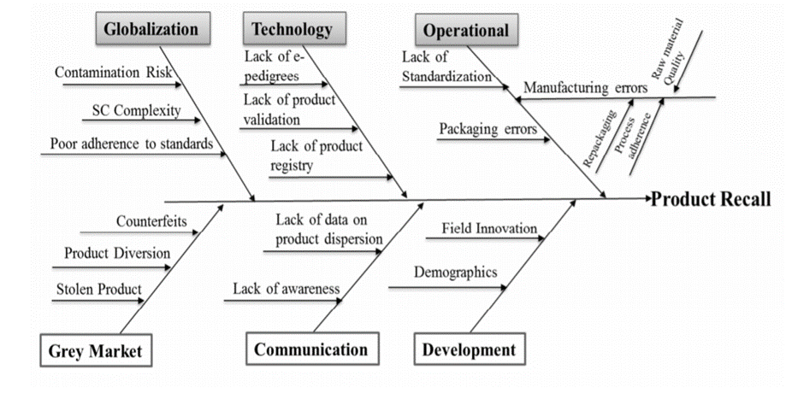

Conmed had 271 products recalled from 2006 to 2018. We categorized all the products into 8 types of recall reason and get each reasons’ number, we make a chart as below. We figure out that the top 3 reasons are quality issue, packaging issue and particulate issue (incorrect assembling). As far as we are concerned, we believe that medical equipment has many parts and complex production processes, and flawed products will inevitably appear. Based on this situation, we think we should put some more efforts on the parts that can be easier manipulated, packaging issues, mislabeling assembling issues fits our strategy perfectly. We can find out there are 121 recalls belong to these three reasons, which takes account of 44% of all the recall products. If Conmed could improve the internal quality management system, we can reduce the recall numbers of these three reasons.

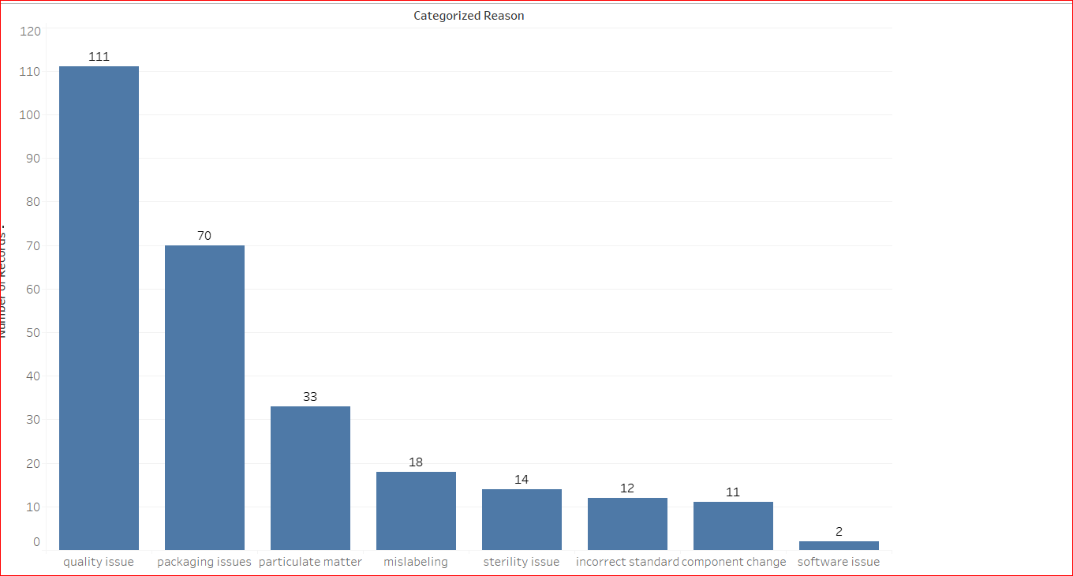

In addition, we find the recalled distribution among Conmed corp and its subsidiary corporation categorized by each reason. We can find in the below chart, Conmed Endoscopic Technologies, Inc. contributes for the most mislabeling recalls. If subsidiary corporation explains as detailed as possible in the label and establishes strict labeling standards, we think the mislabeling number of CET will have some decrease.

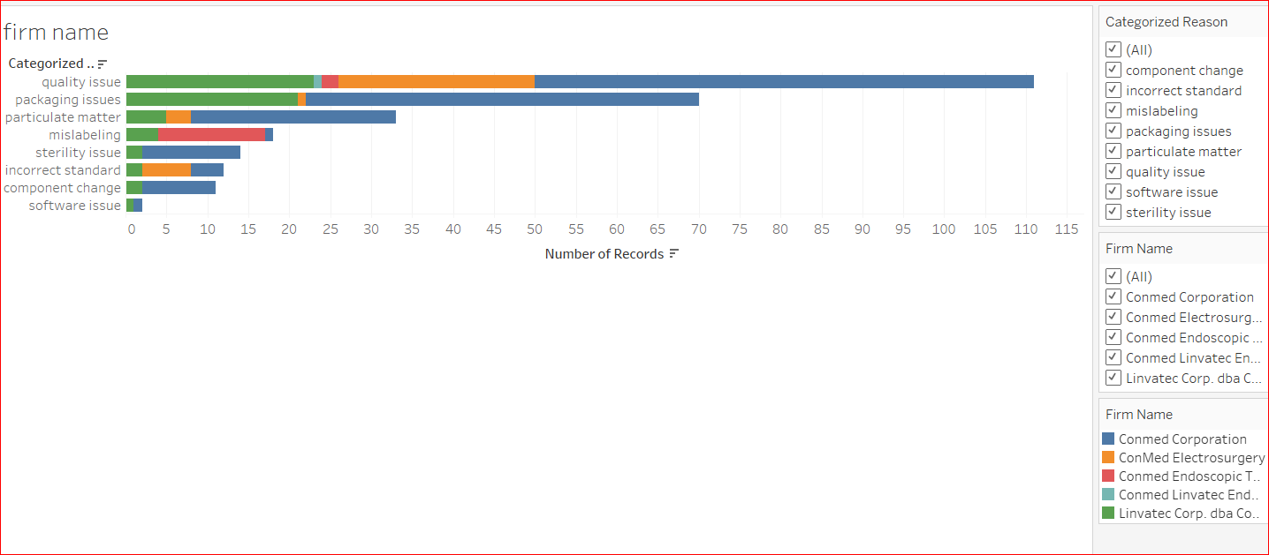

**References**

Pedersen, A. (2019). Medical Device Recalls Were Way Up in 2019. *Medical Device and Diagnostic Industry*. Retrieved 14 Jan 2020, from<https://www.mddionline.com/medical-device-recalls-were-way-2019>.

Sanders, D. (2016). Demystifying Healthcare Data Governance. Retrieved on 14 Jan 2020, from<https://www.healthcatalyst.com/wp-content/uploads/2015/03/Executive-Report-demystifying-healthcare-data-governance.pdf>.

Trends in medical device recalls retrieved on 18 Mar,2020, from

<https://www.medtechintelligence.com/feature_article/trends-in-medical-device-recalls/>

Conmed Medical device recalls retrieved on 12 Feb, 2020, from

<https://www.accessdata.fda.gov/scripts/cdrh/cfdocs/cfres/res.cfm>